Problem Statement

You are working as a DevOps Engineer in a company named Sanders & Fresco Pvt ltd. You have been asked by your manager to create a Maven Project using Jenkins and build a war file of that project. As a proof of concept, you have been given a web application to build. And once done with building the war file, deploy it over the tomcat server. Steps to solve:

• Open Jenkins and create a Maven project using it. 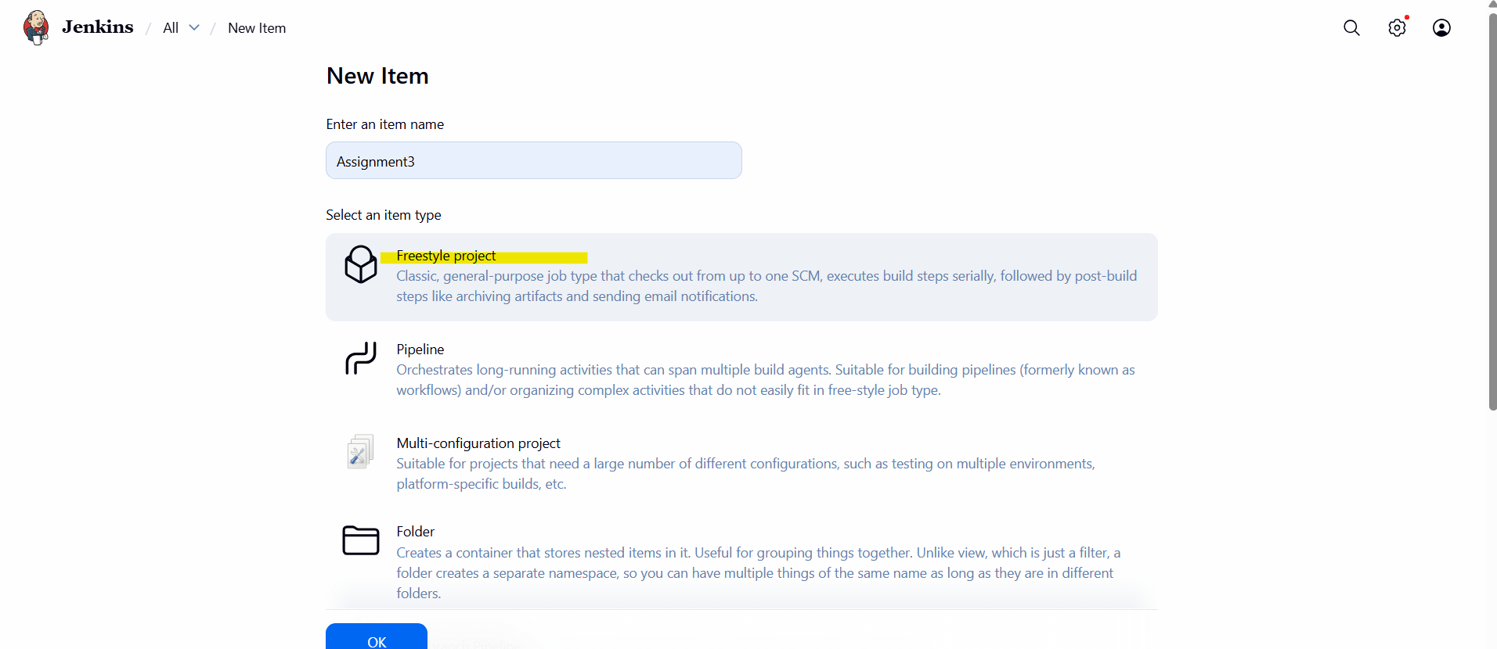

• You will have to create the following jobs, which are as follow:

o Compile

o Code Review

o Unit test

o Package

o Deploy 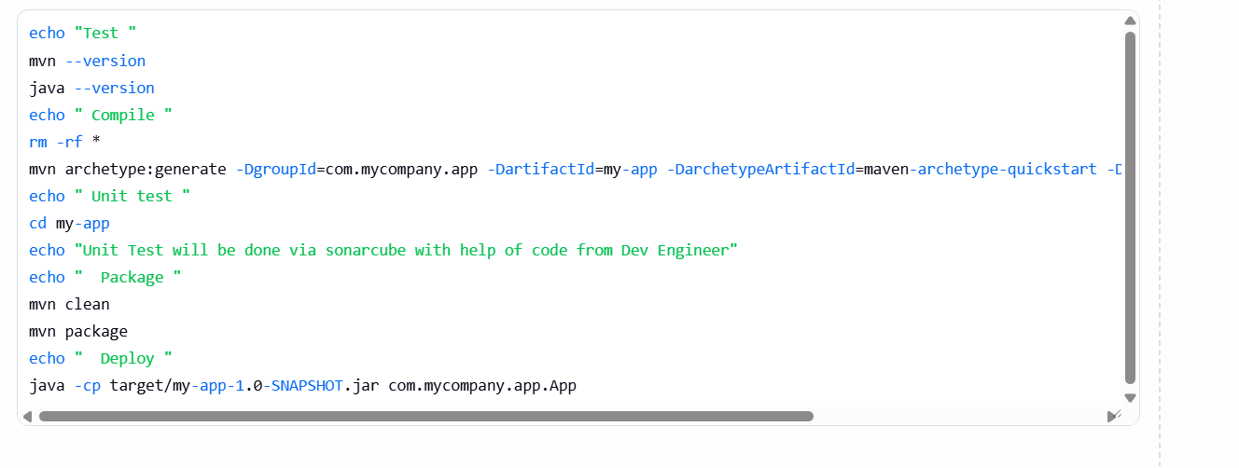 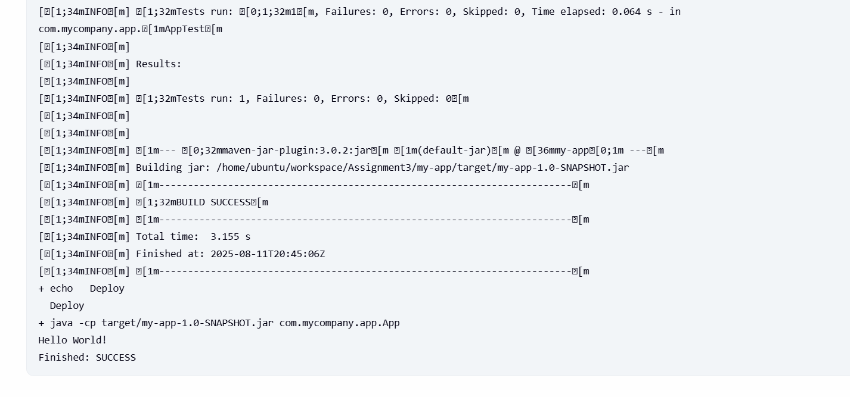

You have to complete your job within the given time frame.